**Shoroog almalki**

Artificial Intelligence in Robotics

**Part 1**

**Create 2 nodes shared a string message in a**

**custom package :**

**1 – Create catkin workspace :**

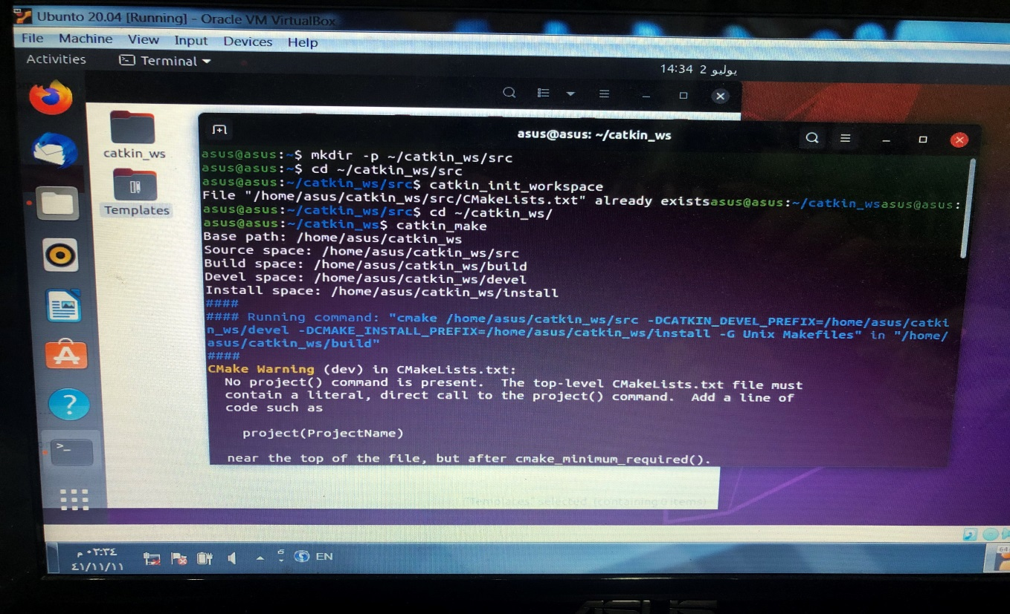

**2- Create package :**

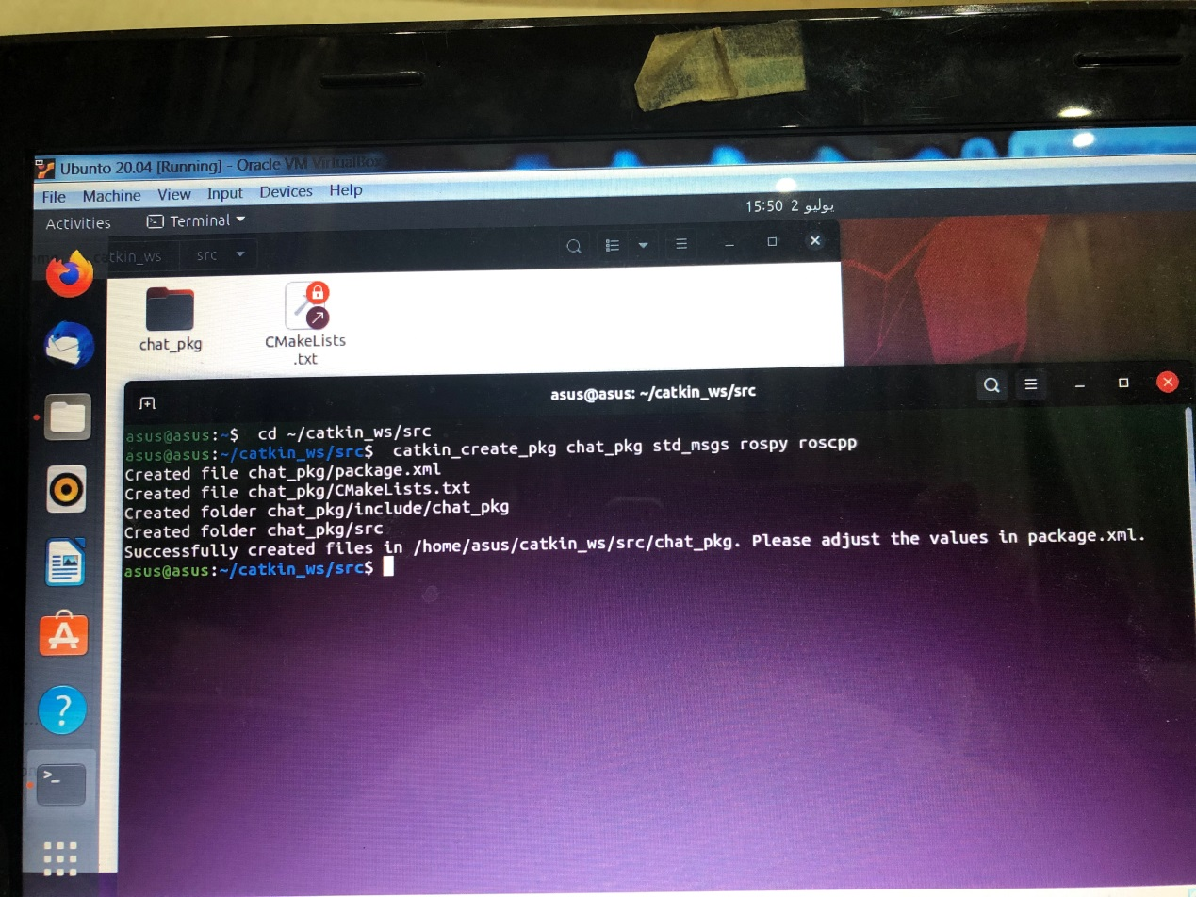

**3-Open the editor and write the commands**

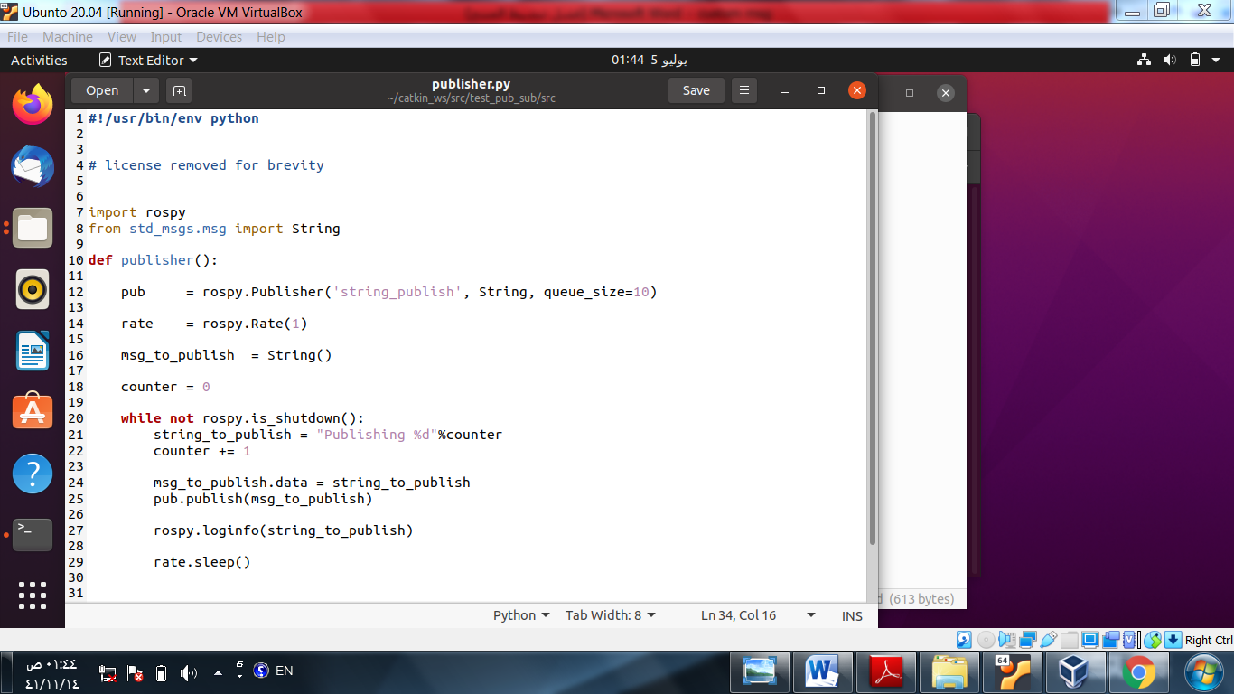

**4- Go back to the terminal to install the package to standard messages :**

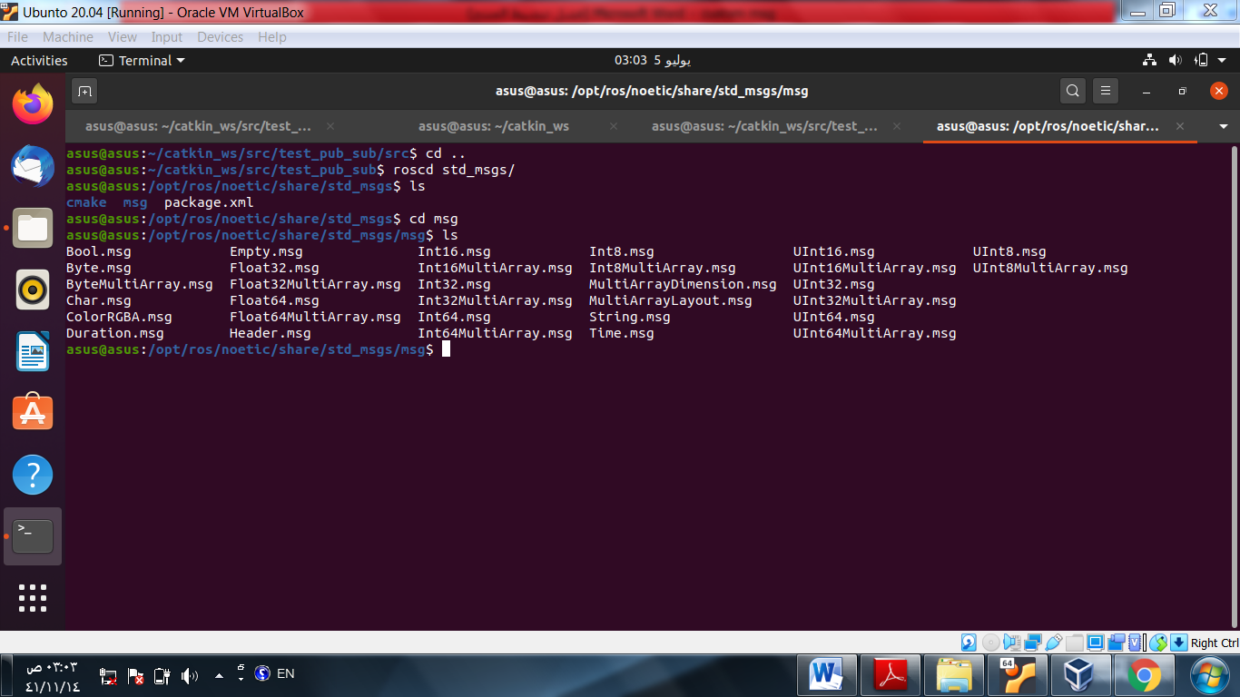

**5 - The message in this example is composed on String data :**

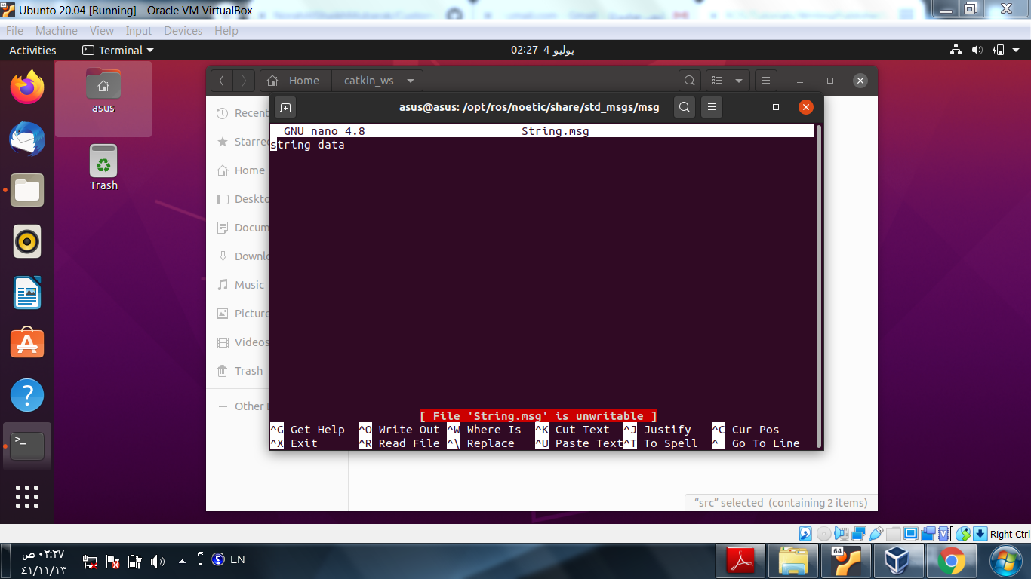

**6- Go back to editor and complete the code for the publisher :**

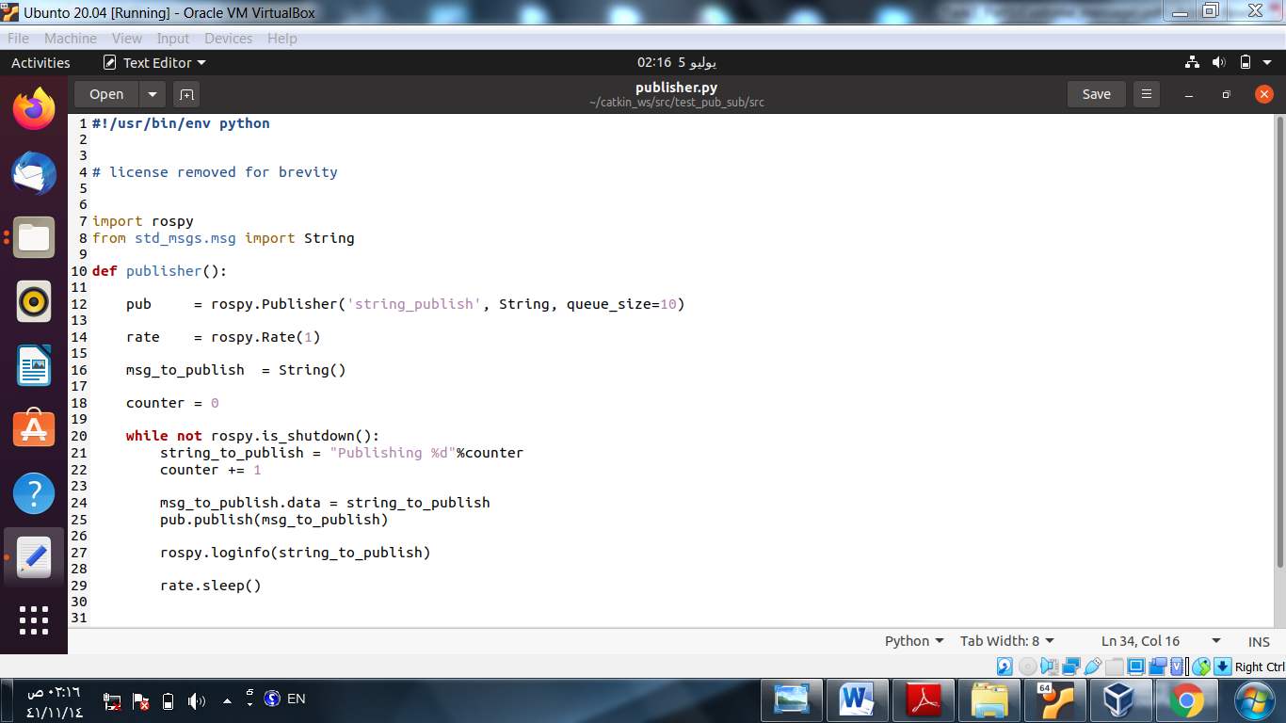

**7 - Compile the catkin workspace**

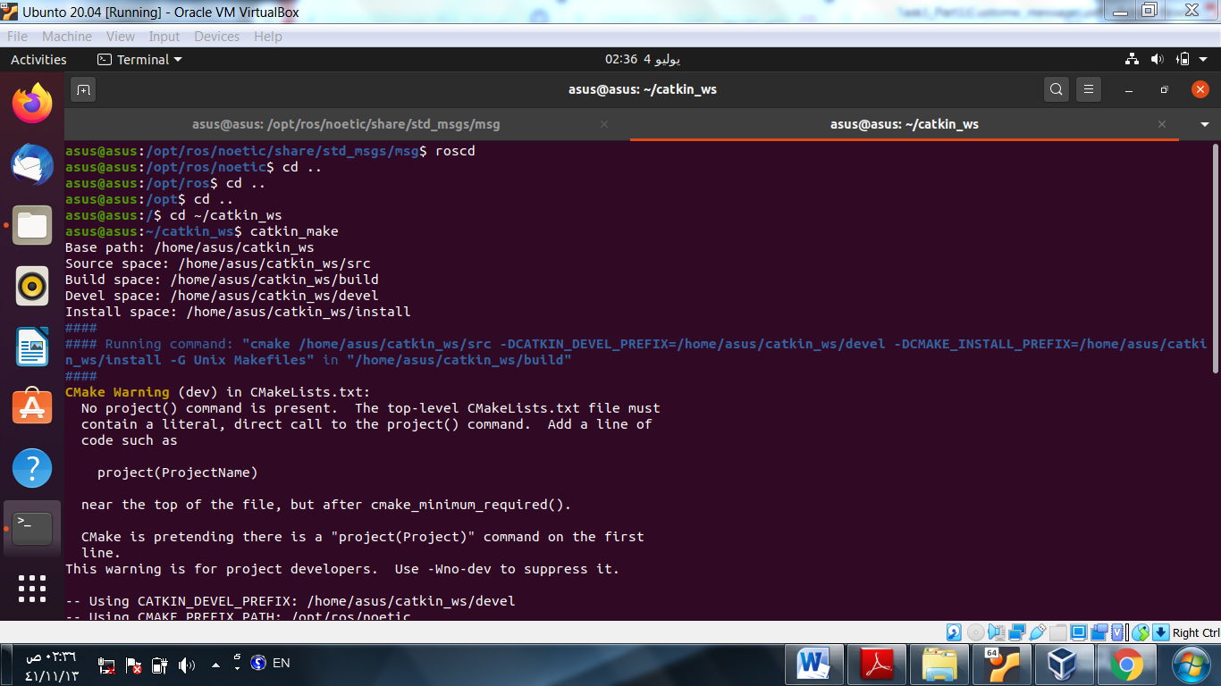

**8- Source the environment**

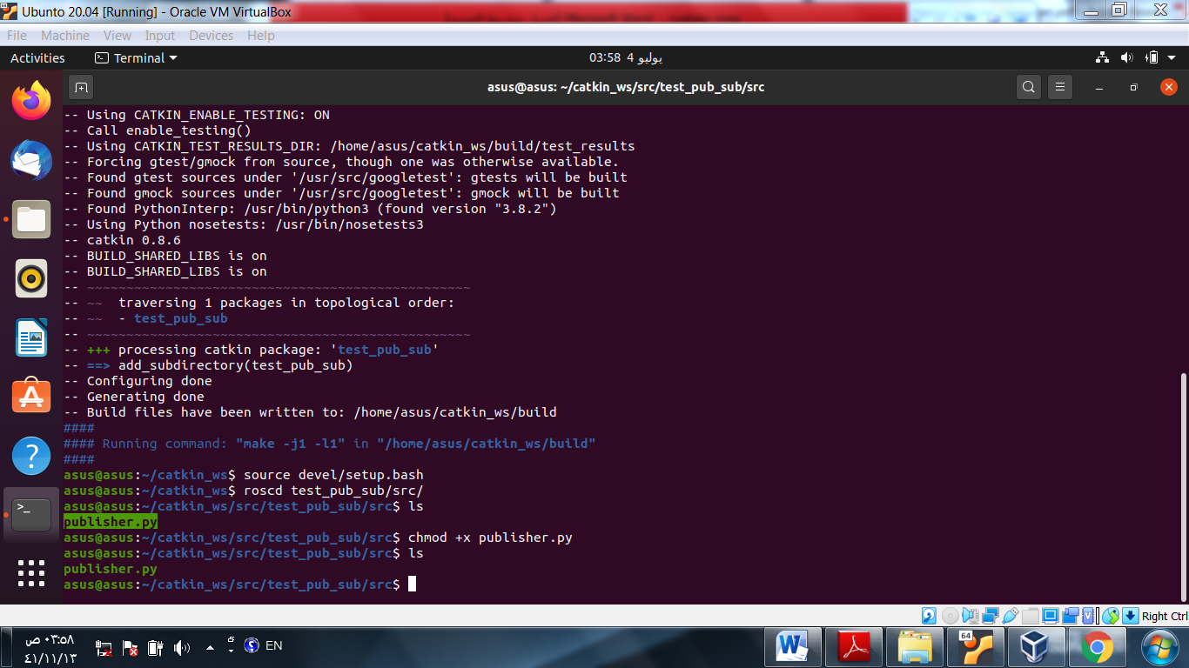

**9- Run the publisher:**

* create new windows
* write roscore to launch

- run the publisher in the other window

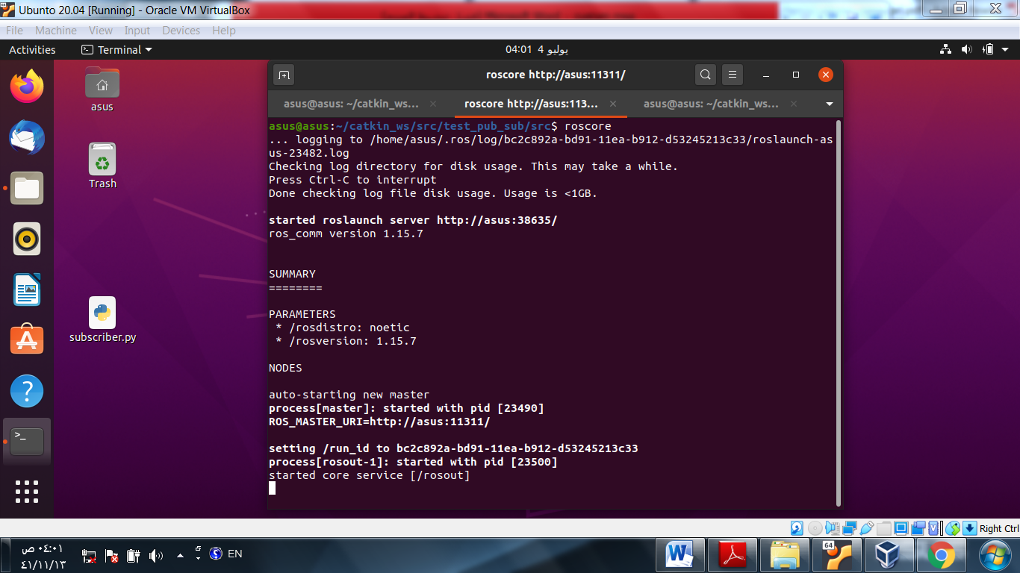

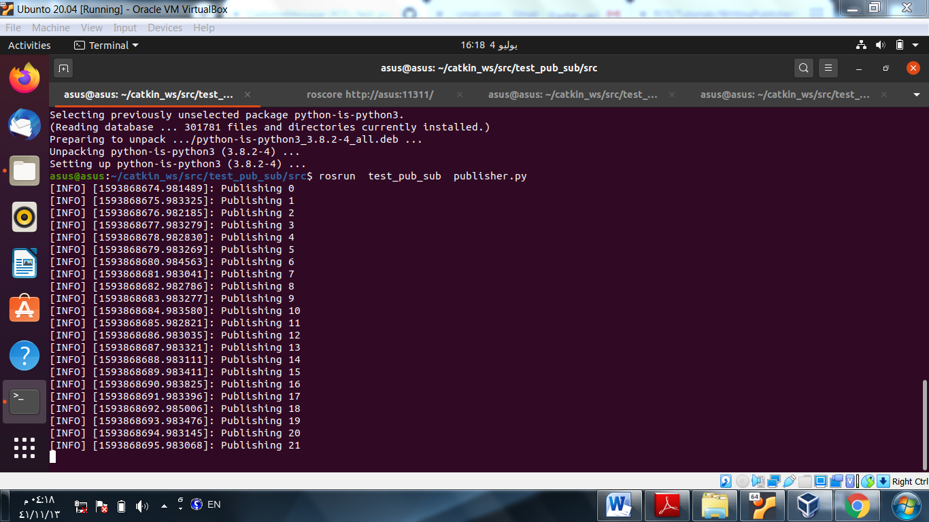

**10- Verify the topic :**

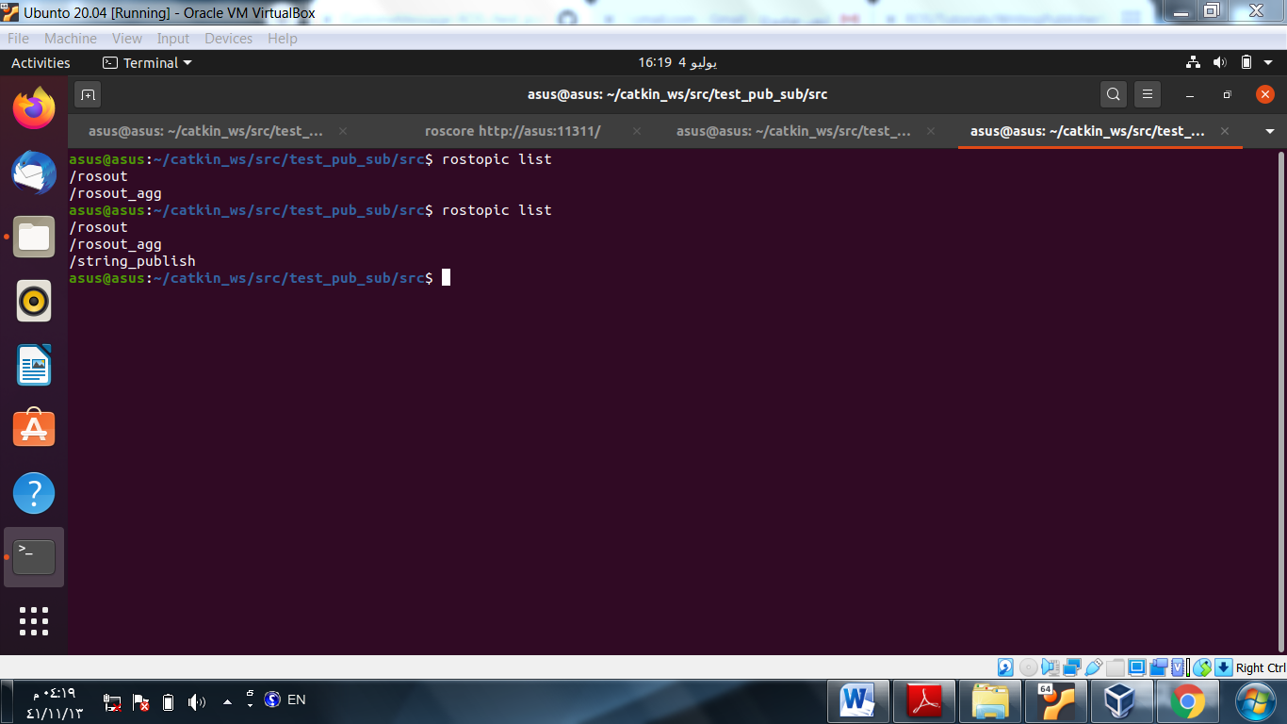

**11- Print the topic message**

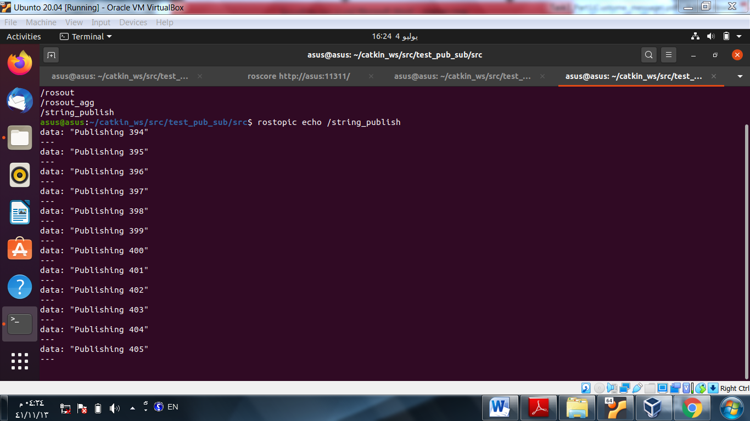

**Create subscriber node**

1. **Write the subscriber node**

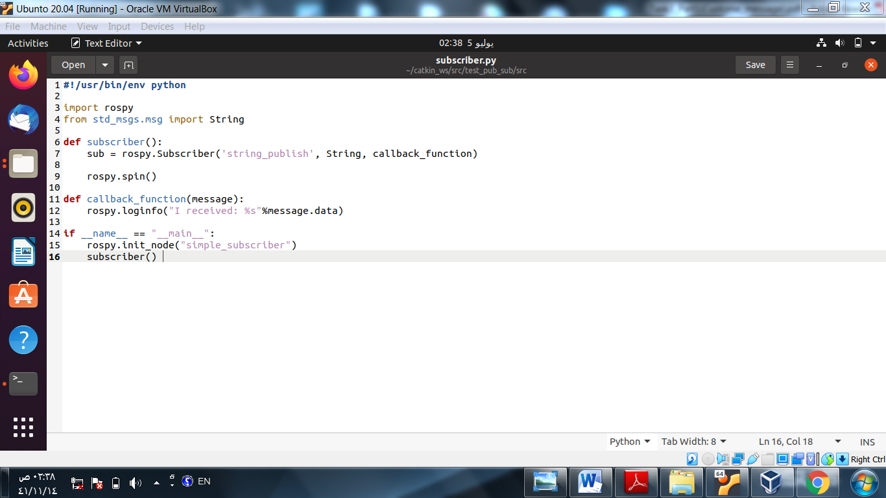

1. **Make the subscriber file executable**

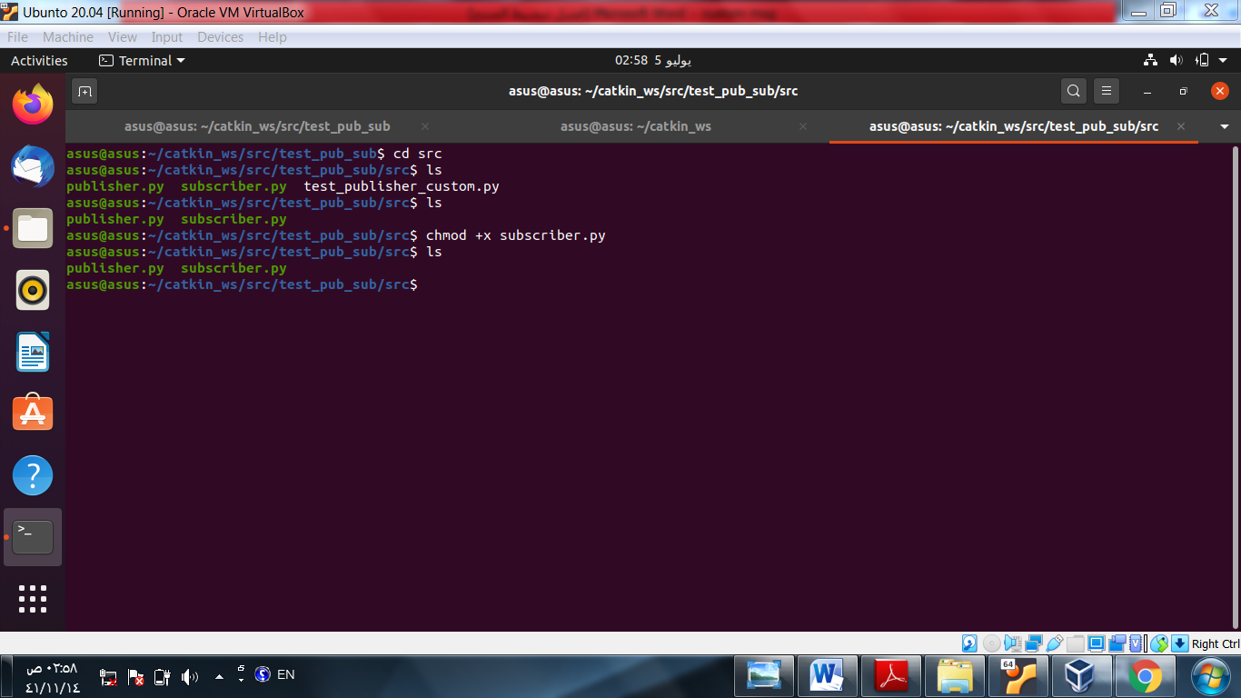

1. **Run the subscriber**

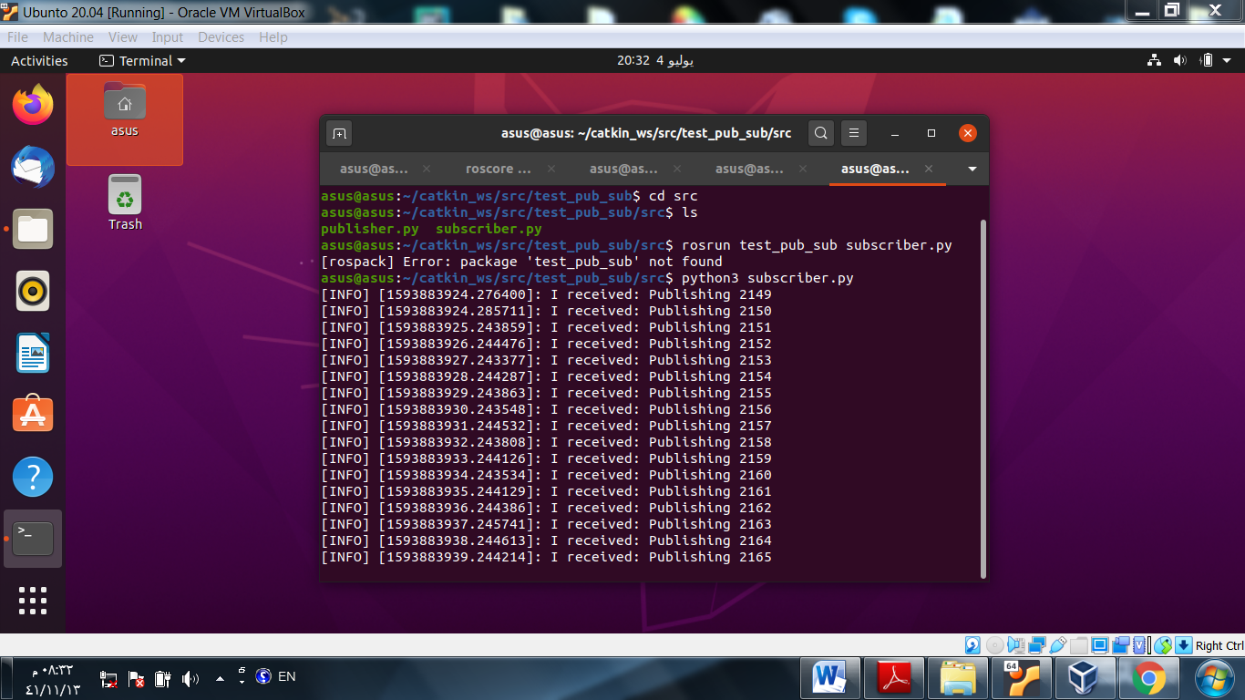

1. **Graphical view between the subscriber and publisher**

**(output)**

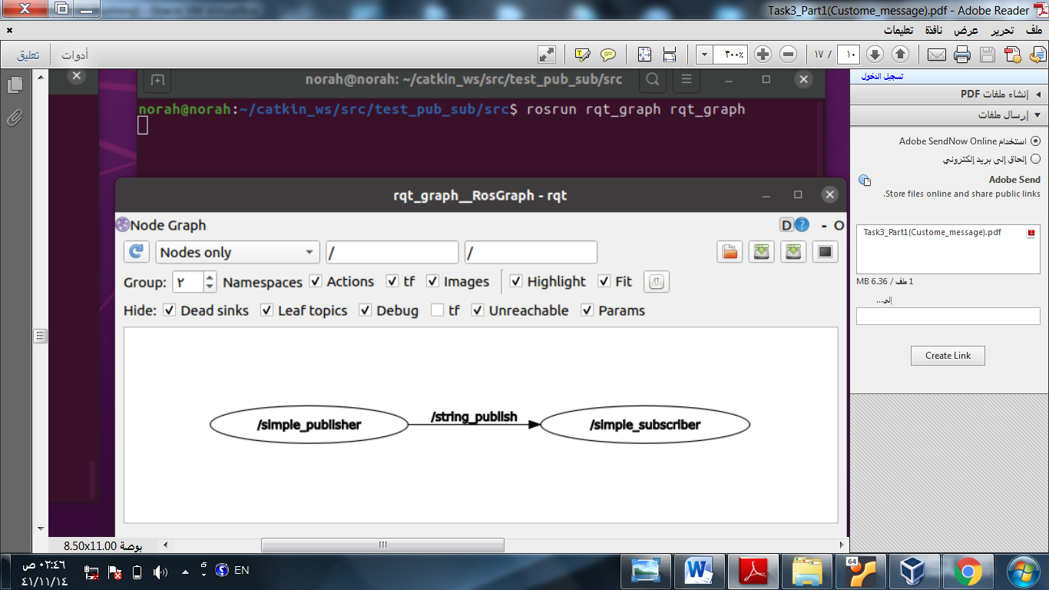

**create a custom message**

**1 - Create a msg folder inside the package**

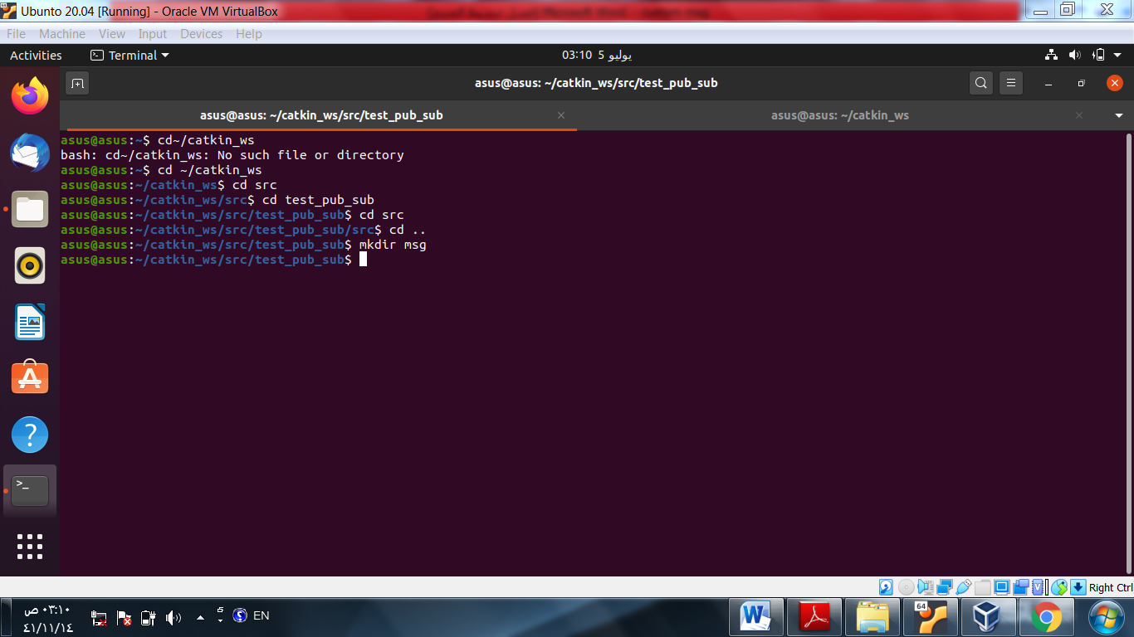

**2 -Create a custom message file and save it in the msg folder**

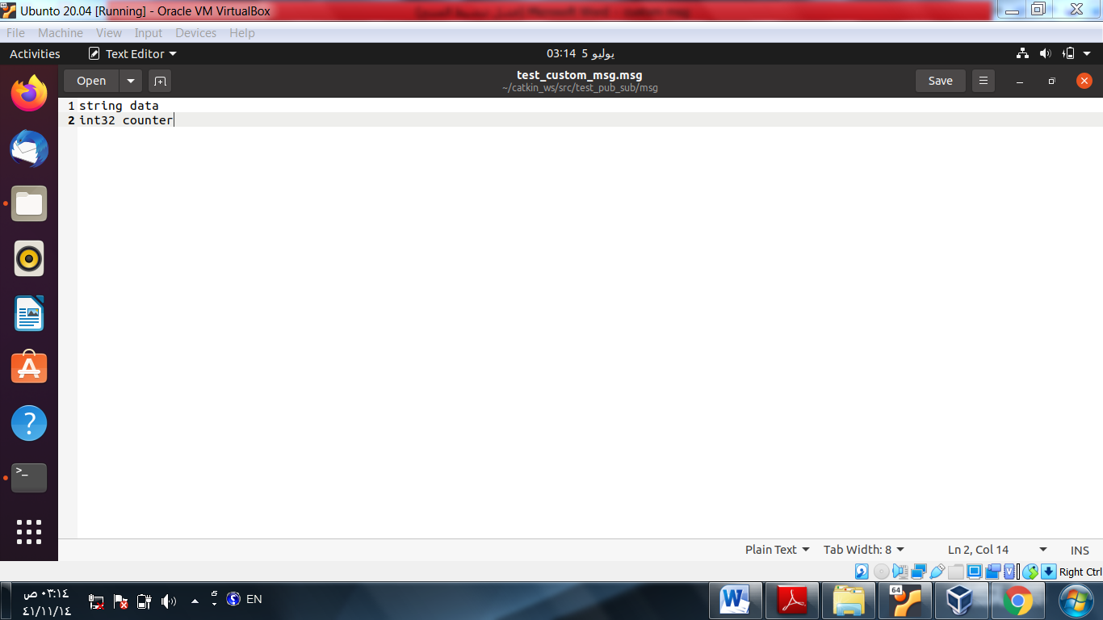

**3 - Modify package.xml and Cmakelist file inside the package**

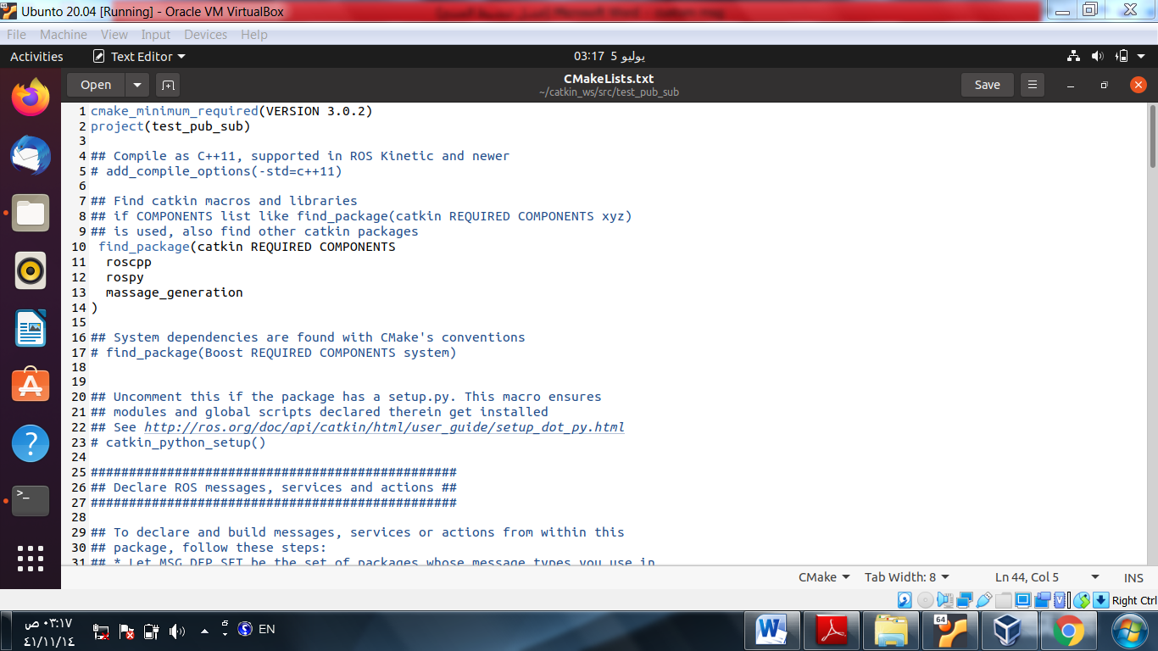

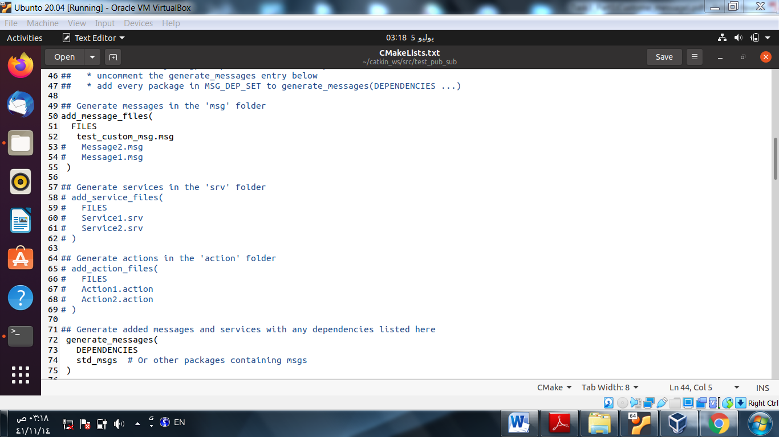

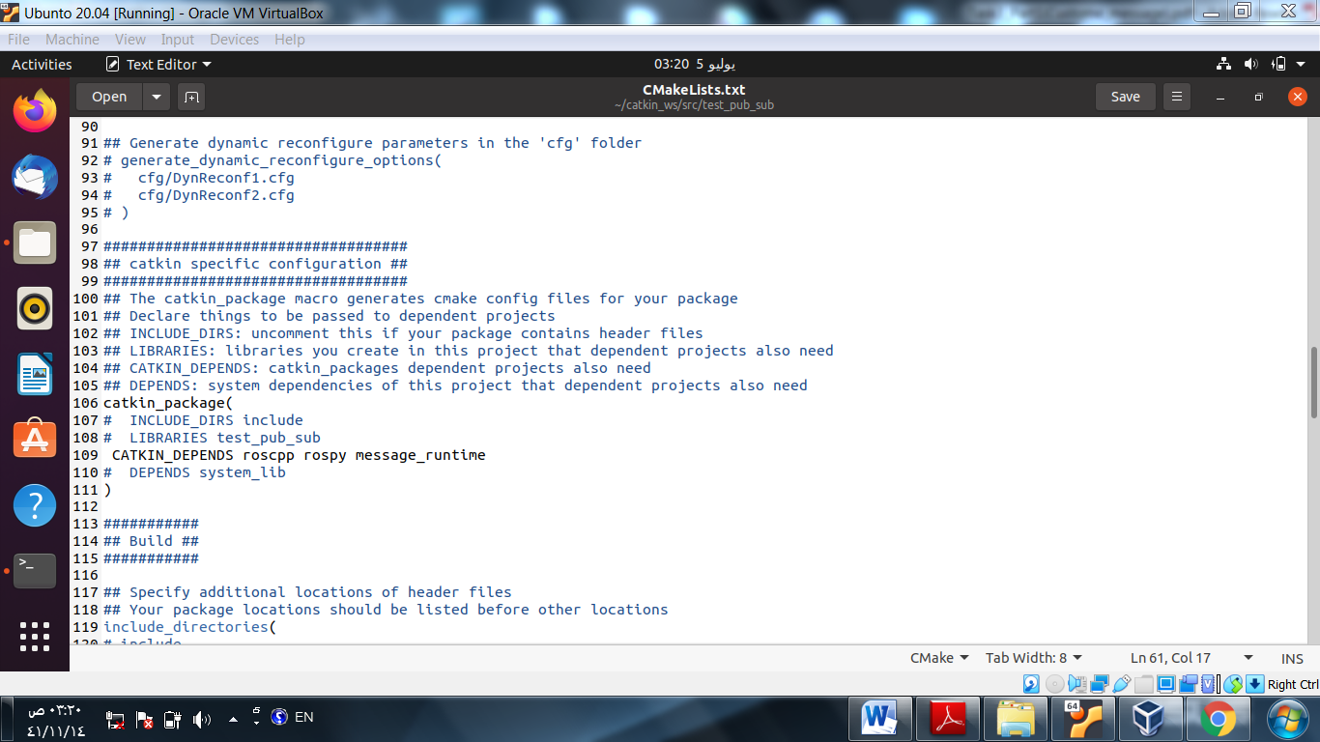

**4 - Open the package.xml and modify it**

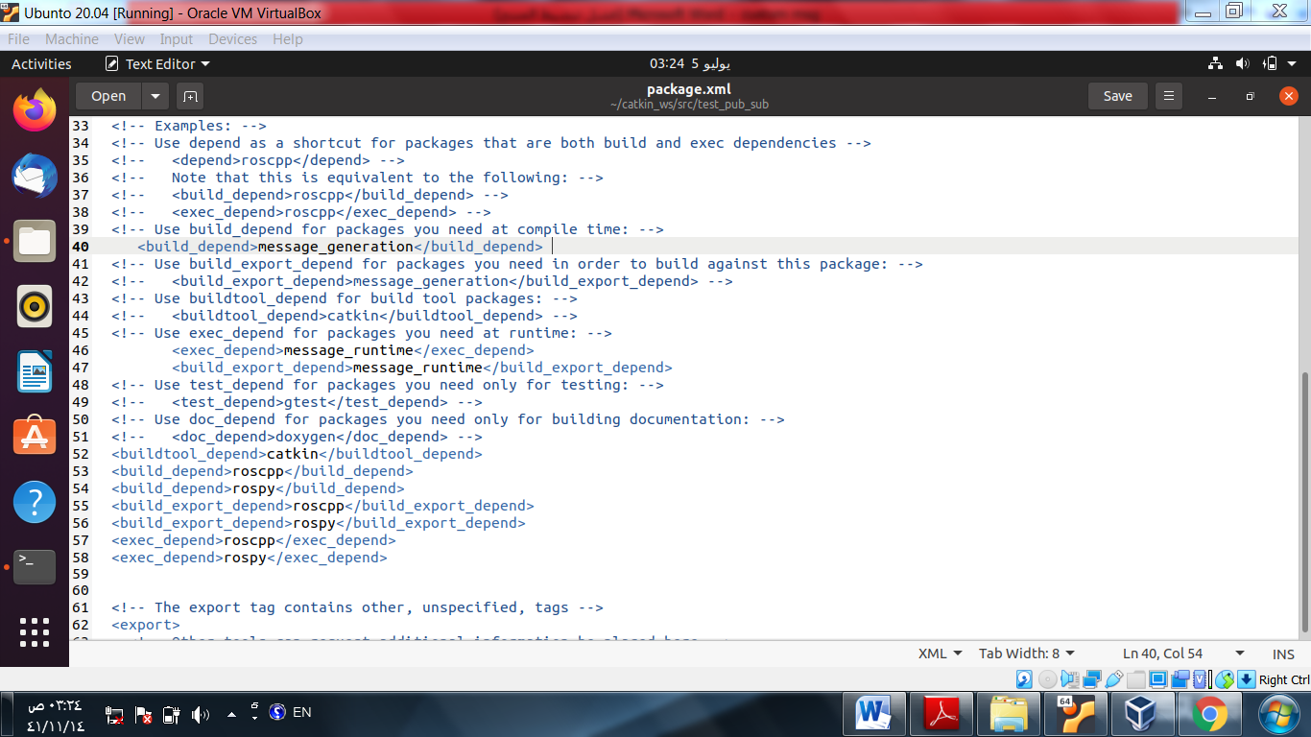

**5 - Run catkin_make and observe the changes** :

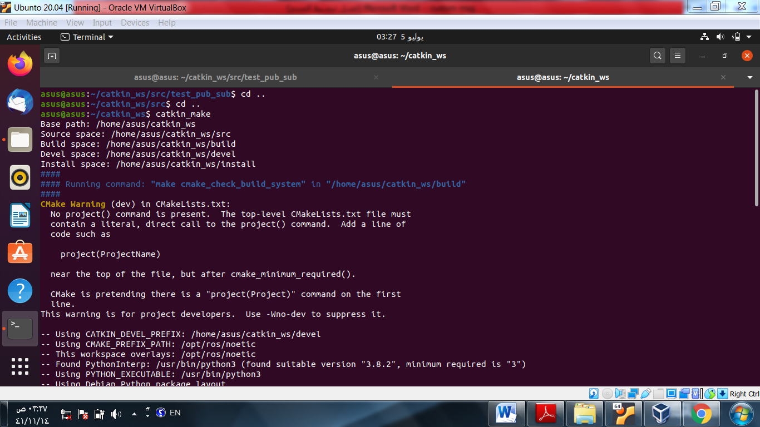



6 - **Modify the publisher and subscriber code**

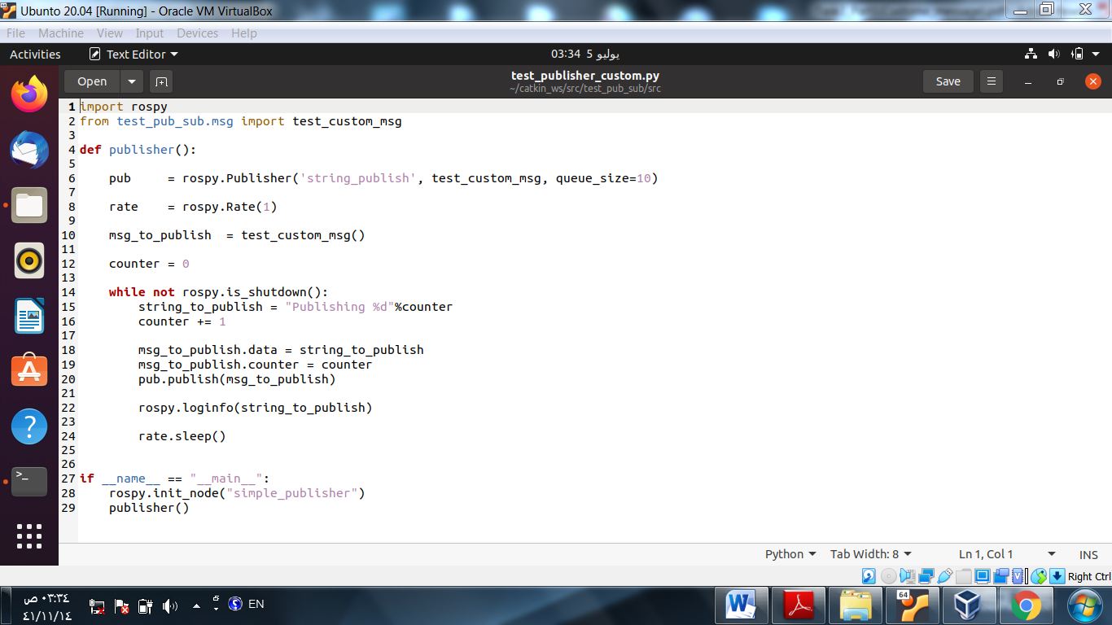

**7 - Make the file executable**

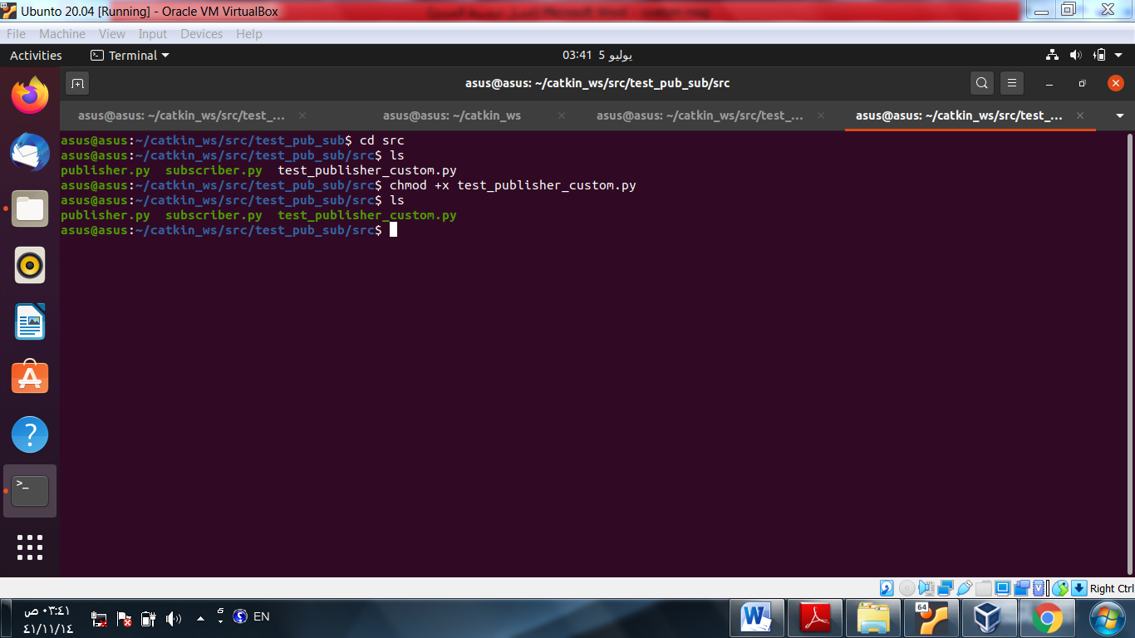

**8- Modify the subscriber node**

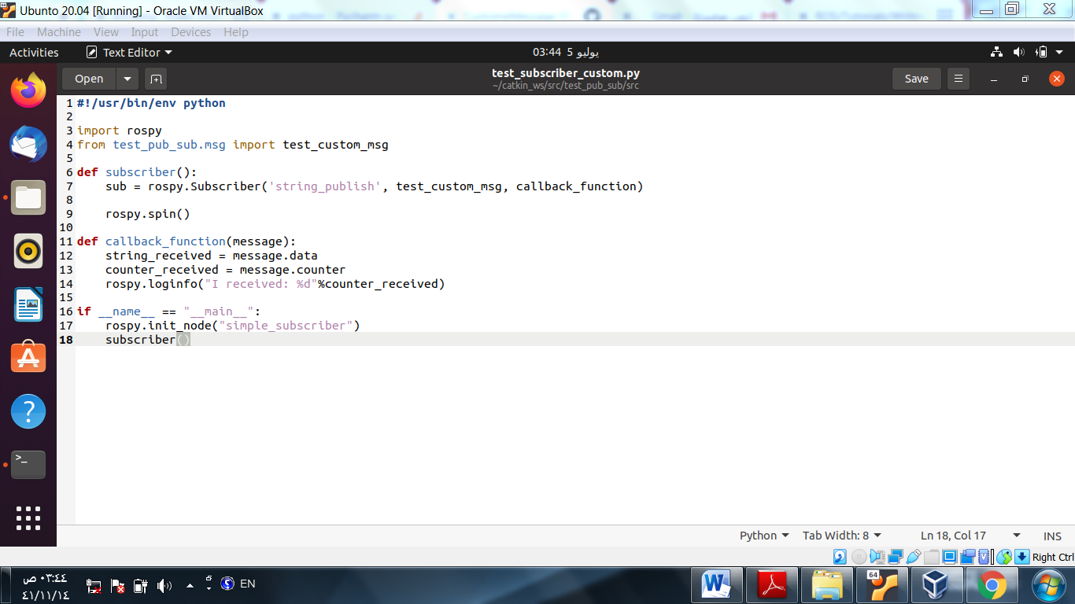

**9- Make the file executable**

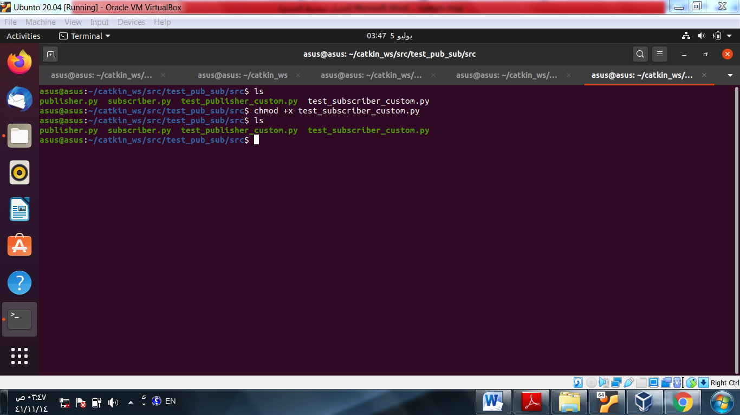

**10 - Run the publisher node**

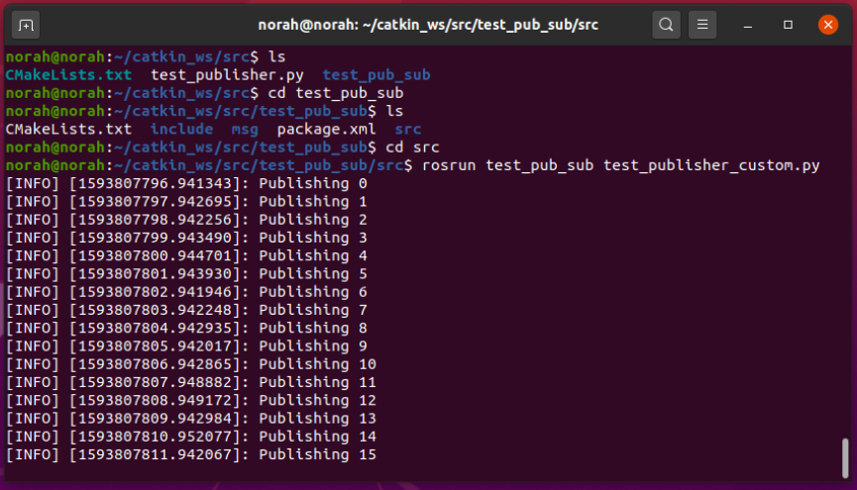

**11 run subscriber :**

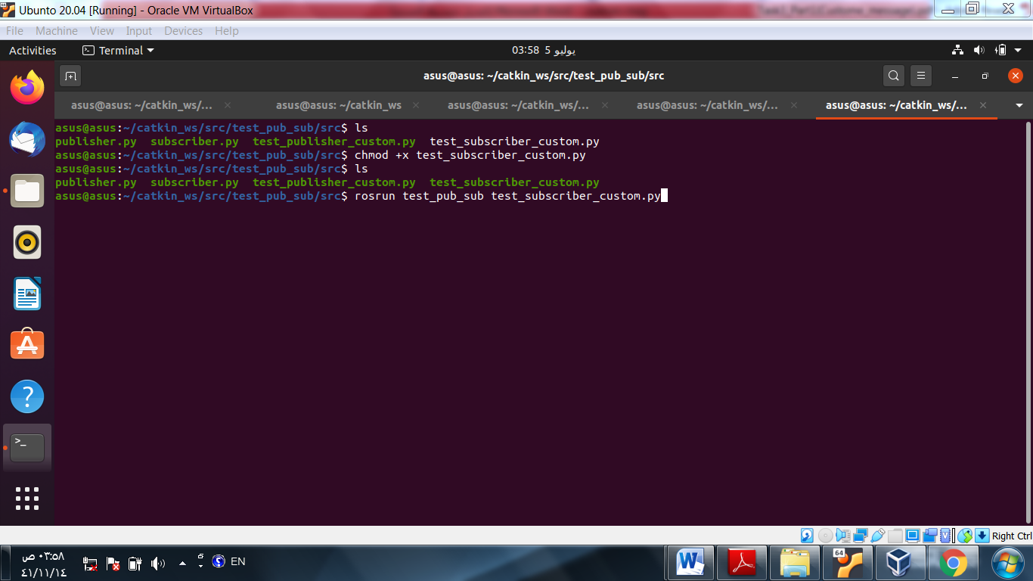

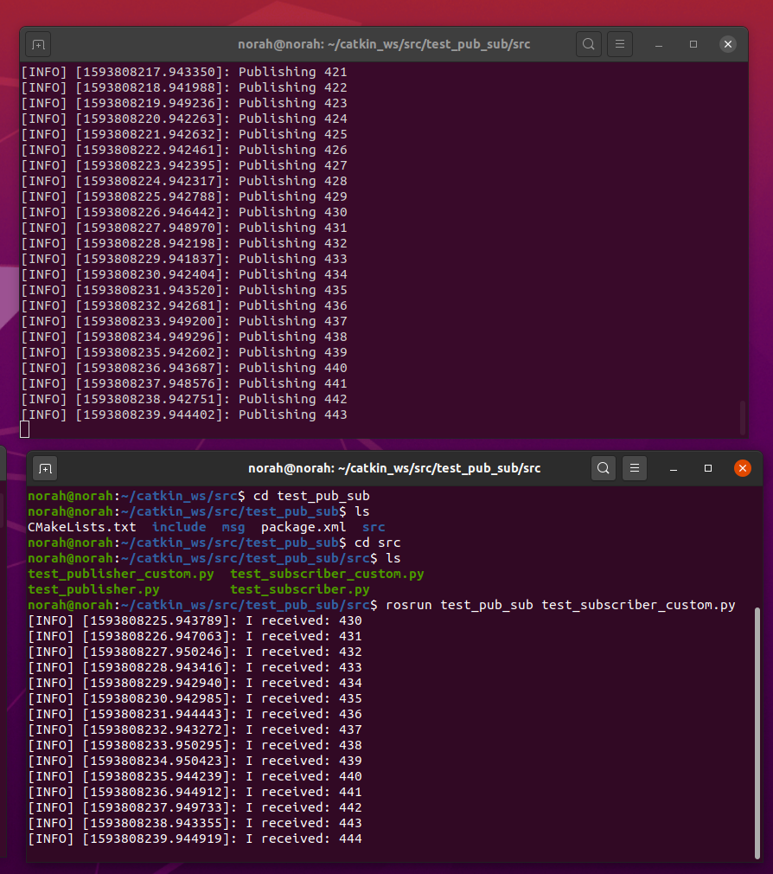

**12 - Create rqt_graph**

**(output)**

